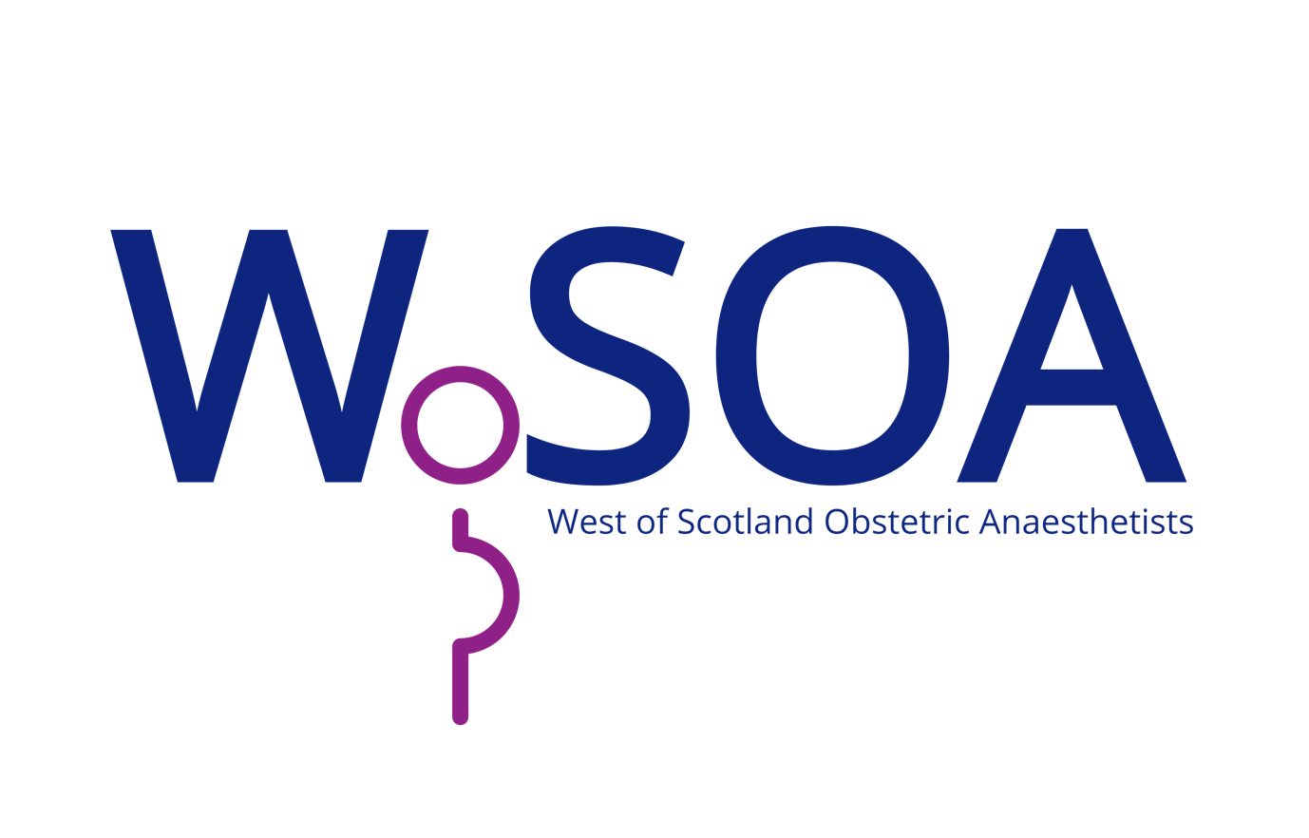

Certificate of Attendance

ICU deliveries during COVID

attended this meeting for 1CPD point

5th August 2021

Dr Malcolm Broom
Secretary, WoSOA
